**KĨ THUẬT LÀM BÀI SPEAKING**

**4 parts. B1 B2 C**

**Phần 1: (10s - 30s)**

* trả lời ngắn, xem file thầy gửi (tài liệu nói phần 1)

**Phần 2: (30s - 45s)**

* Miêu tả tranh.

Cần từ vựng:

* Màu sắc, tuổi tác
* Đồ mặc: Hat- mũ, cap- mũ lưỡi trai, dress- váy, skirt- chân váy, shirt-áo sơ mi,
* T-shirt-áo phông, pants -quần dài, jeans-quần bò, shorts-quần sooc, bag-cái túi hoặc ba lô, glasses-kính, shoes-giày, play-chơi, read- đọc, sit- ngồi, Stand- đứng.
* In the picture, I can see … people/man/boy/ girl/ woman. They are/ He is/ She is … (ở đâu)

- (On the left/ on the right/ in the middle) of the picture, … is … (ai đang làm gì)

* … is wearing … (đang mặc gì)
* I think they are….. (excited/happy/sad) because they are doing what they (like/dislike).
* **Ngoại cảnh ngoài trời.** In the background, there are some (có thể nói “trees/houses/ /chairs” nếu ko biết từ nào khác)….. something like that. I can’t see clearly.

**Hoặc trong nhà:** On the table, I think there are some (có thể nói “glasses/fruits” nếu ko biết trên bàn có cái gì)…… I’m not sure.

* I guess after this, they are going to (go home/ the movies/have dinner/lunch)
* Looking at the picture, I feel like I want to … ( nói “be like them too” nếu ko biết lắp gì vào ba chấm)

**Cấu trúc cù lần dùng để kéo dài PART 2 và 3**

**PHẦN DỄ (chống liệt)**

Câu hỏi phụ:

* Kéo dài bằng cách đọc lại câu hỏi như sau
* **So my question is …**

Rồi nhét thêm 1 trong các câu sau ở đầu: (HỌC 2 CÂU CỦA MÌNH)

* To be honest I didn’t expect such a hard question...but let me see, ….
* I think I need a moment to think of the right word to talk about my ideas for this question.
* Well, to be honest, I don’t have much knowledge about this. But I think my answer is…
* I’m really not sure about the answer. But if I really must answer, I think …
* Oh, that’s a hard question. I’ve never really thought about it. I guess…
* This question is really difficult. Nobody has ever asked me about that before. Wow, let me think about that. I guess…

Nhét 1 câu vào cuối câu: (HỌC 2 CÂU CỦA MÌNH)

* I think it is an interesting question and I’m not sure my answer is correct but I hope I have given my opinion clearly
* And That is the end of my answer, Thank you for giving me such an interesting topic to think about.
* That is my answer, I don’t think many people will choose like me, but I won’t have a different answer even in the future
* To be honest, that is a very hard topic for me because I have never thought about it before. But I think my answer was clear enough for you to understand.
* Frankly speaking, that is a very hard topic for me because I have never thought about it before. But I think my answer was clear enough for you to understand.
* If I were a friend my age, I think my answer would be different. But I have always been a strange person, so I hope my answer is enough for this question.

Ngữ pháp, từ vựng, phát âm, dễ hiểu.

**NÂNG CAO (Điểm tốt hơn)**

Câu trả lời của các câu hỏi how, where, when, how many, who, why, what

* **Why:**

The reason why I . ……**..**. Is because …., I always want to … whenever I have the chance.”

* **Where / When : Kể về địa điểm, việc làm nào đó. Trong câu hỏi có các chữ sau (tell about… Describe … What did you do….what was the last time?)**

The last time I… was last month. It’s an amazing …..(place/experience) It has always brought me good memories. Even though I want to …… more often, I can’t because I have to work a lot now.

* **What/How …. Feel:**

I am so (excited/ happy) when I … (có thể dùng “do it”). I always want to do it whenever I have free time, but I am so busy now. I hope I can …… again (soon / next month/ next week)

**- What:**

I can say that … is the most amazing …. I have ever ……..

**- Who:**

Me and my ….. went to …. together although we didn’t have a lot of time. I wish I could turn back time to when we were kids so we could spend more meaningful time with one another without worrying about money and work.

**- How did you go there?**

We were very lucky because one of my friends had a minibus. he is a driver and he knows all of the places that we want to go to. I have to say that he is such a dependable friend that we can always count on.

VD: Nói: Ngữ pháp, từ vựng, trôi chảy, phát âm, độ mạch lạc.

- So my first question is Tell me a time you used internet.

* To be honest I didn’t expect such a hard question...but let me see, ….
* The last time I used the internet was last month. It’s an amazing experience. It has always brought me good memories. Even though I want to use the internet more often, I can’t because I have to work a lot now.

**Phần 3: Tả tranh đôi**

* Both pictures show ….
* In the first picture, ….. . Tả người. I think so.
* While in the second picture, …………. Tả người. I guess, I can’t see clearly.
* Although they are doing different things, they all seem (happy/ sad)
* Looking at the picture, I want to ….. like them too

**Phần 4: 1 phút để chuẩn bị (có giấy bút) 2 phút để nói**

1. Tell me a time you helped someone?

2. How did you feel?

3. Do people need to have other people?

Format: When, Why, Who, What, how many, How often, How,

So my first question is Tell me a time you helped someone?

* Cù lần nhét đầu: I’m really not sure about the answer. But if I really must answer, I think …
* I think it was last week, I helped an old woman cross the street. Actually, she is my neighbor, I have known her for a long time. She was trying to buy something in the shop next to my house. When I saw her, there were a lot of vehicles/cars on the street, so I helped her and she thanked me.

My second question is How did you feel?

* I guess I felt happy/ excited/ phenomenal/sad. I rarely help someone because I go out only when I go to work and I don’t even talk much at the office. When I went home and told my mother, she praised me a lot.

And my last question is Do people need to have other people?

* nhét đầu: To be honest I didn’t expect such a hard question...but let me see, ….
* Of course, Everyone needs someone to help them sometimes. Even if you are super rich, or super healthy, There will be times when you need some one to talk to, or to help you. For example, I was sick last week, so my (husband/ wife/ sister/ mother) took care of me. If I were alone, I think I would be very sad.
* Nhét cuối: Frankly speaking, that is a very hard topic for me because I have never thought about it before. But I think my answer was clear enough for you to understand.

Điền những từ sau để câu giờ:

Well ….

So ….

You know….

Actually ….

I think …

I guess …

I’m not sure, but maybe ….

In my opinion ….

I will tell you my answer….

My answer is …..

Ví dụ:

 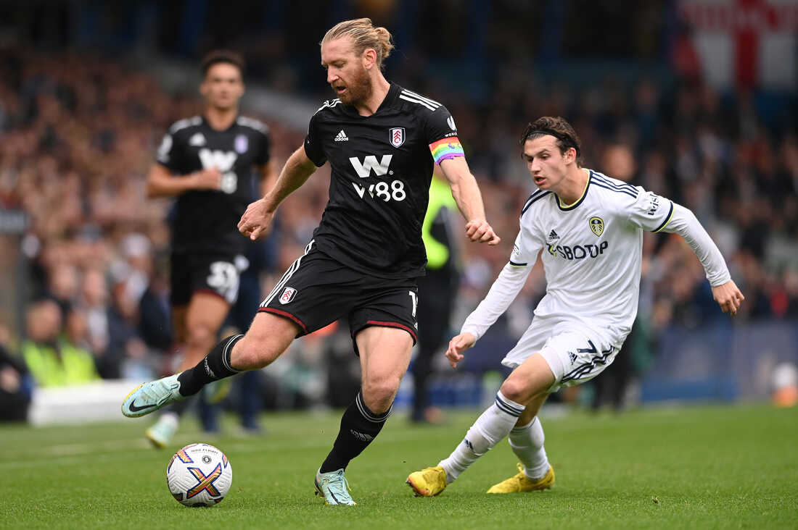

* Both pictures show people playing sports
* In the first picture, a girl is playing tennis. She is wearing a white tanktop and a white skirt. She is about 20 years old. I think so.
* While in the second picture, a man is kicking the ball. He is wearing a black t shirt and black shorts. I guess, I can’t see clearly. Behind him, a man in white uniforms is trying to take the ball from the man in black.
* Although they are doing different things, they all seem (happy/ sad/tired)
* Looking at the picture, I want to soccer like them too
* Casch 1:
* Both pictures show people playing sports
* In the first picture, I can see a girl. she is wearing a white tank top and a white skirt. I guess she is about 20 years old. She is playing tennis.
* While in the second picture, there are two men. they are playing football. In the middle of the picture, the man is wearing a black t shirt and black shorts. Behind him, a man in white uniform from the other team is trying to take his ball. I guess, I can’t see clearly.
* Although they are doing different things, they all seem happy
* Looking at the picture, I want to play sports like them too

Cach 2:

* Both pictures show people playing sports
* In the first picture, a girl is playing tennis. She is wearing a white tanktop and a white skirt. She looks like she is about 20 years old. I think so.
* While in the second picture, two men are playing football. I guess, I can’t see clearly. One man is wearing a black t shirt and black shorts. He is about 30 years old. The man on the right is wearing a white t shirt and white shorts. He is trying to take the ball from the man in black uniforms.
* Although they are doing different things, they all seem happy
* Looking at the picture, I want to play sports like them too

**DE 7:**

Part 2:

* Miêu tả tranh.

Cần từ vựng:

* Màu sắc
* Đồ mặc: Hat- mũ, cap- mũ lưỡi trai, dress- váy, skirt- chân váy, shirt-áo sơ mi,
* T-shirt-áo phông, pants -quần dài, jeans-quần bò, shorts-quần sooc, bag-cái túi hoặc ba lô, glasses-kính, shoes-giày, play-chơi, read- đọc, sit- ngồi, Stand- đứng.

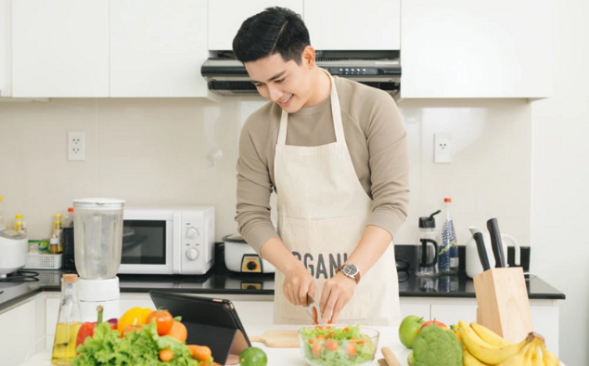

* In the picture, I can see 1 man. He is in the kitchen
* in the middle of the picture, the man is cooking / slicing some tomato
* he is wearing a grey t shirt/sweatshirt/ an apron
* I think he is happy because he is doing what he likes

On the table, I think there are some vegetables and fruits. I think so.

* I guess after this, he is going to have dinner
* Looking at the picture, I feel like I want to cook a healthy meal for my family.
* In the picture, I can see a man. He is in the kitchen

- in the middle of the picture, the man is cooking/ slicing a tomato/ smiling

* He is wearing a grey t-shirt/ sweater/ white apron. I’m not sure, I can’t see clearly.
* I think he is happy because he is doing what he likes

On the table, I think there are some fruits and vegetables.

* I guess after this, he is going to have dinner
* Looking at the picture, I feel like I want to cook a healthy meal too
* Đồ mặc: Hat- mũ, cap- mũ lưỡi trai, dress- váy, skirt- chân váy, shirt-áo sơ mi,
* T-shirt-áo phông, pants -quần dài, jeans-quần bò, shorts-quần sooc, bag-cái túi hoặc ba lô, glasses-kính, shoes-giày, play-chơi, read- đọc, sit- ngồi, Stand- đứng.
* In the picture, I can see a man. He is in the kitchen

- in the middle of the picture, he is cooking/ slicing a tomato

* he is wearing a grey t shirt/ and a white apron
* I think he is happy because he is doing what he likes

**Hoặc trong nhà:** On the table, I think there are some vegetables and fruits.

* I guess after this, he is going to have dinner
* Looking at the picture, I feel like I want to cook healthy meals for my family

2. Describe the last time you prepared a healthy meal.

So my question is Describe the last time you prepared a healthy meal.

* To be honest I didn’t expect such a hard question...but let me see,

It was last week, we had a party at my home. So we made some salad and chicken. It tasted good and also good for your health. I think we will make more healthy food next week.

when, where, how, who, which, what, how many, how often.

It was last week, we had a party at my home. Me and my friends held this party together and invited our teachers and parents. We made some salad and boiled 5 chickens. We also bought a lot of coke. We don’t often hold big parties like this so it’s a good chance for everyone to know each other. It was really an unforgettable party for all of us, we had a lot of fun.

3. Why do people eat unhealthy food?

My question is Why do people eat unhealthy food?

I think the reason why people eat unhealthy food is because they are tasty. Moreover, unhealthy food usually takes a little time to buy from the restaurant. Actually, I ate a hamburger this morning

* That is my answer, I don’t think many people will choose like me, but I don’t think I will have a different answer even in the future

Part 3:

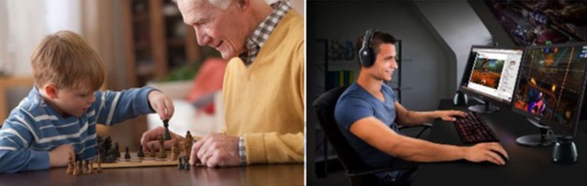

Part 3:

1. Tell me what you see from two pictures?

Both pictures show people who are relaxing

- In the first picture, there are two people, one child and his grand father, they are playing chess together. I think so. The grand son is wearing a blue t shirt and his grandpa is wearing a yellow sweater

- While in the second picture, a boy is playing game on the pc or watch a film. I guess, I can’t see clearly.

- Although they are doing different things, they all seem happy because they are smiling

- Looking at the picture, I want to play chess with my father like them too. I also love playing online games with my younger brother.

2. Which one do you prefer?

I think I like computer games more because it is more lively and I like action games. I want to go to the world in the game.

3. How have games changed in the past 50 years?

Games have changed a lot. They are more realistic now. There are a lot of games now while in the past, there were only some games

Part 4:

1. Tell me a time you helped someone?

It was last week, I helped my mom buy some meat and vegetables from the store.

2. How did you feel?

I felt like I was very helpful and I was happy because I did something useful

3. Do people need to have other people?

Of course, we need other people to help us, and if we help other people, we will feel happy, too

**Ví dụ:**

DE 8: HAY THI

Part 2:

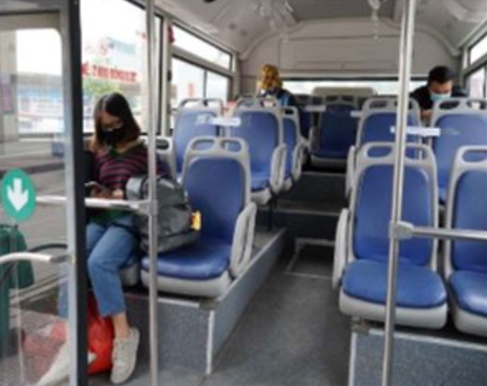

* In the picture, I can see 3 people. They are on a bus
* On the left of the picture, a girl is using her phone
* she is wearing a black sweater and blue jeans. On the back, There are two people, I guess they are also using their phones, I can’t see clearly.
* I think they are tired because they are going home after a long day.
* In the background, there are many empty seats.
* I guess after this, they are going home to have dinner
* Looking at the picture, I feel like I want to go home too.

1. Describe the picture?

Bài tham khảo:

In the picture, I can see 3 people

They are staying on a bus

On the left of the picture, a girl is looking at her phone. I think She is wearing a black T shirt and blue jeans. She is also wearing white shoes.

I can’t see clearly the two people at the back, but they are all wearing masks, I guess this picture was taken in the covid 19 pandemic. In the background, there are some trees outside the windows, something like that. I can’t see clearly.

I guess after this, they are going to go home. Looking at the picture, I feel like I want to go home with my family.

2. The last time you traveled by bus?

Từ vựng ngữ pháp trôi chảy hoàn thành

It was last week. I travelled by bus with my friends. We went to Ho nui Coc to play on our holiday. It was an exciting trip. On the way back, we bought a lot of souvernirs for our friends and family. It was an unforgettable trip because all of the friends in my class were able to join this trip.

* **So my question is** The last time you traveled by bus
* Well, to be honest, I don’t have much knowledge about this. But I think my answer is last week

3.what are some useful ways for people to avoid boredom when traveling by bus'?

* I think using the mobile to surf the internet is a good way to avoid boredom. And That is the end of my answer, Thank you for giving me such an interesting topic to think about.

Nâng cao: I think using the mobile to surf the internet is a good way to avoid boredom. I am a young person and I find it hard to go anywhere without my phone, especially when I travel by bus. The reason is very simple, I have nothing to do on the bus and it usually takes about half an hour of travel, so I need the phone to watch some funny clips or read news about my favorite singers. It really helps.

Part 3:

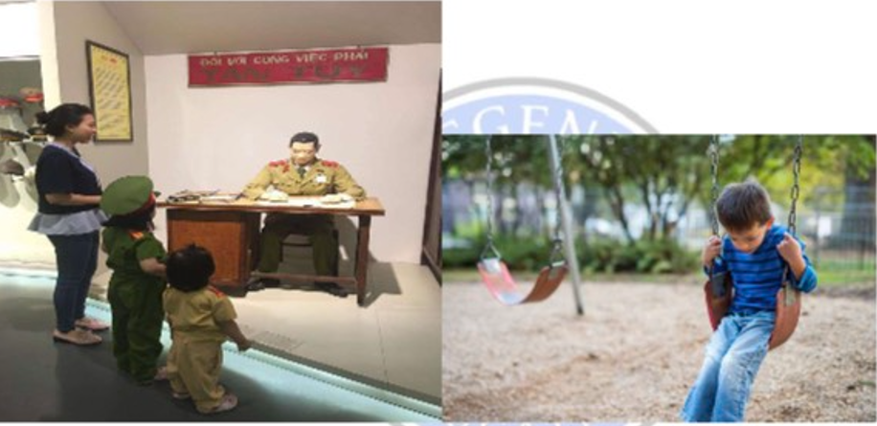

1. Tell me what you see from the two pictures?

Both pictures show some children

In the first picture, there are 3 people at a museum, they are looking at a figure. I think they are a family, a mother and two daughters, I think

In the second picture, A boy is playing swing alone. I think he is waiting for his father or mother.

The kids in the picture on the left seem happy because they are with their mother but the kid in the picture on the right is a bit sad. Maybe he just got punished.

Looking at the picture, I feel like I want to go to a museum with my friends.

2. Which activity do you prefer?

I prefer going to the museum with my friends because it is more fun. I can see all the interesting things in the museum.

3. Why is it important for children to take part in different activities?

It is important for children to take part in different activities because they can develop better. They will see more and know more

Part 4:

1. Tell me a time you used Internet?

It was just yesterday, I used the internet to search for the information of my laptop, it was an old laptop so I needed a lot of time to look for its information.

2. What do you use Internet for?

I use the internet to search for the information. I also use it to play games and use facebook or Tiktok

3. Do you think people nowadays use Internet a lot?

Yes, people nowadays use Internet a lot. They use it to play games, use facebook or Tiktok

1. Tell me a time you used Internet?

2. What do you use Internet for?

3. Do you think people nowadays use Internet a lot?

So my first question is Tell me a time you used Internet?

To be honest, this is an unexpected question for me because I use the internet everyday.

My second question is: What do you use Internet for?

I use the internet to search for computer, laptop, play game and work

and my last question is: Do you think people nowadays use Internet a lot?

Yes, i think people nowdays use internet a lot. They use the internet to play game, tiktok, youtube and work

And this is the end of my answer, I hope I have given my opinion clearly